Chinese Name:__________________

Student ID:_____________________

Date:__________________________

1, Chinese characters. Please write each of them for three times in the boxes. Both simplified and traditional form are acceptable.

我：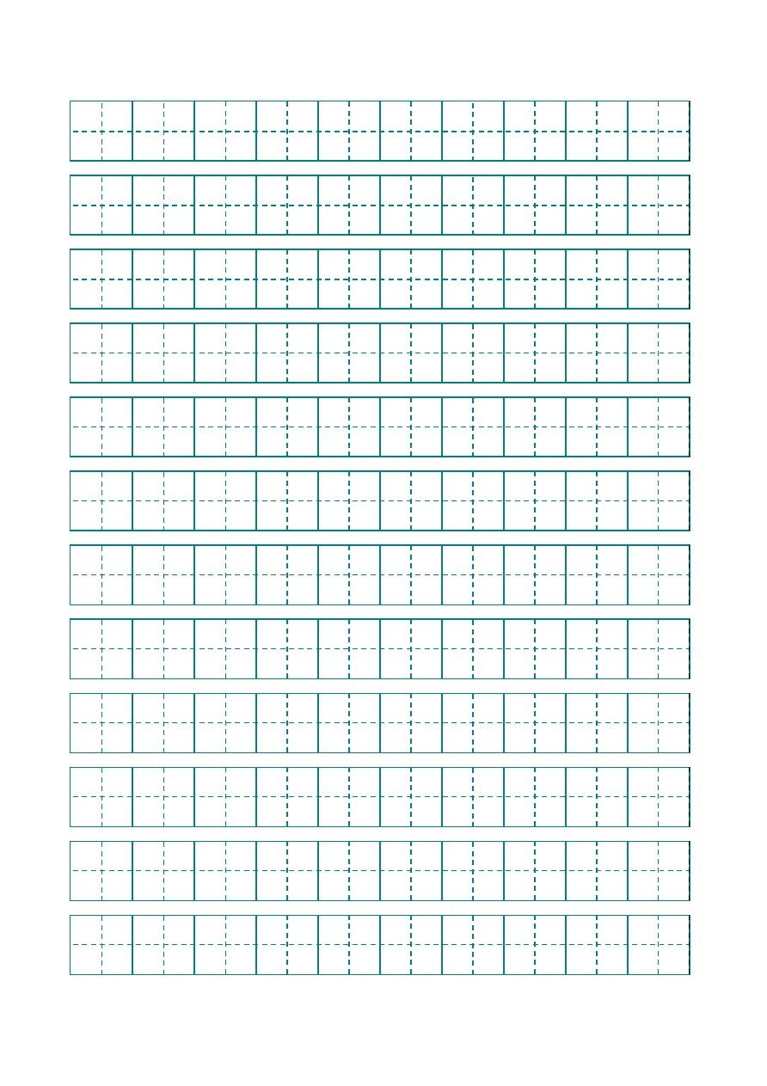 Pinyin:_________, meaning: _________.

你： Pinyin:_________, meaning: _________.他： Pinyin:_________, meaning: _________.

们（們）：Pinyin:_______, meaning: _________.

爸： Pinyin:_________, meaning: _________.

妈（媽）：Pinyin:_______, meaning: _________.

哥： Pinyin:_______, meaning: _________.

弟： Pinyin:_______, meaning: _________.

朋： Pinyin:_______,

meaning: _________.

友： Pinyin:_______,

咖： Pinyin:_______,

meaning: _________.

啡： Pinyin:_______,

喝： Pinyin:_______, meaning: _________.

要： Pinyin:_______, meaning: _________.

好： Pinyin:_______, meaning: _________.忙： Pinyin:_______, meaning: _________.男： Pinyin:_______, meaning: _________.很： Pinyin:_______, meaning: _________.也： Pinyin:_______, meaning: _________.都： Pinyin:_______, meaning: _________.不： Pinyin:_______, meaning: _________.

吗（嗎）： Pinyin:______, meaning: _________.

呢： Pinyin:_______, meaning: _________.

3, Translate the following items to English.

很好：________________

很忙：________________

他们（們）：________________

我们（們）：________________

4, Sentence order: use the following vocabularies to form complete sentences.

1. 呢 很好 我 你

________________________________________________________________

1. 都 咖啡 好 我们 喝

________________________________________________________________